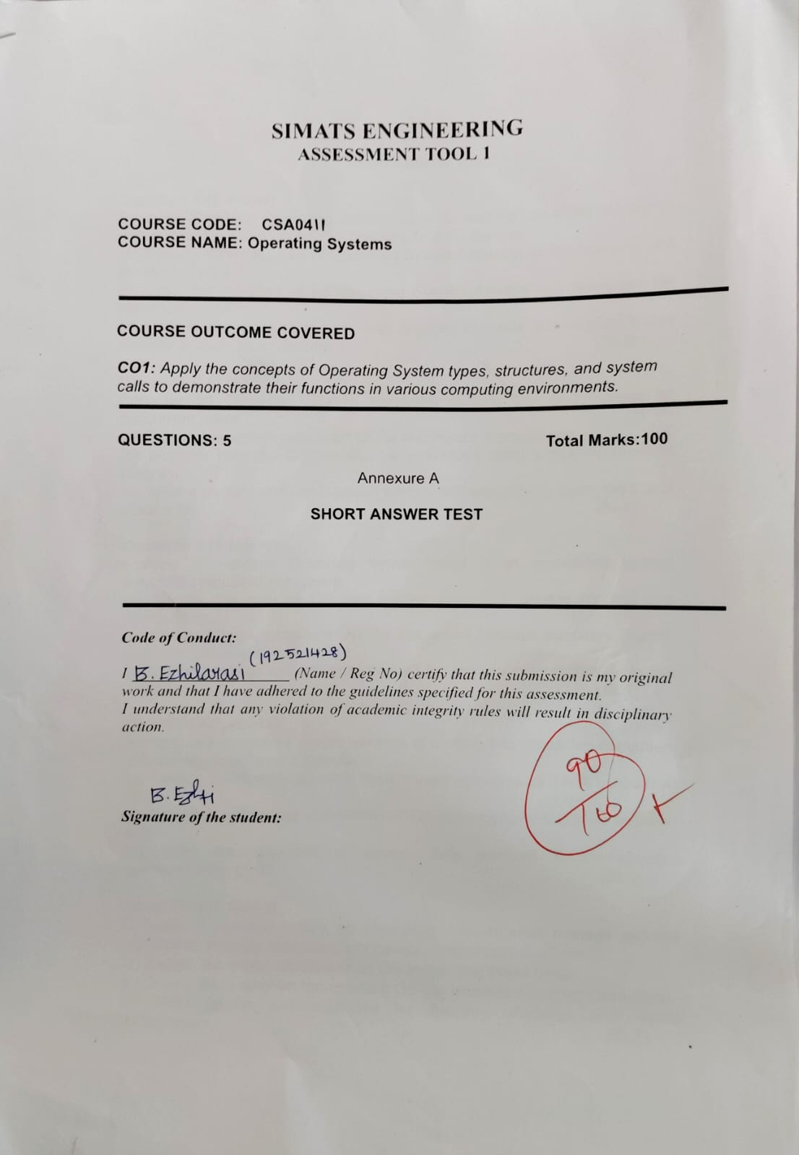
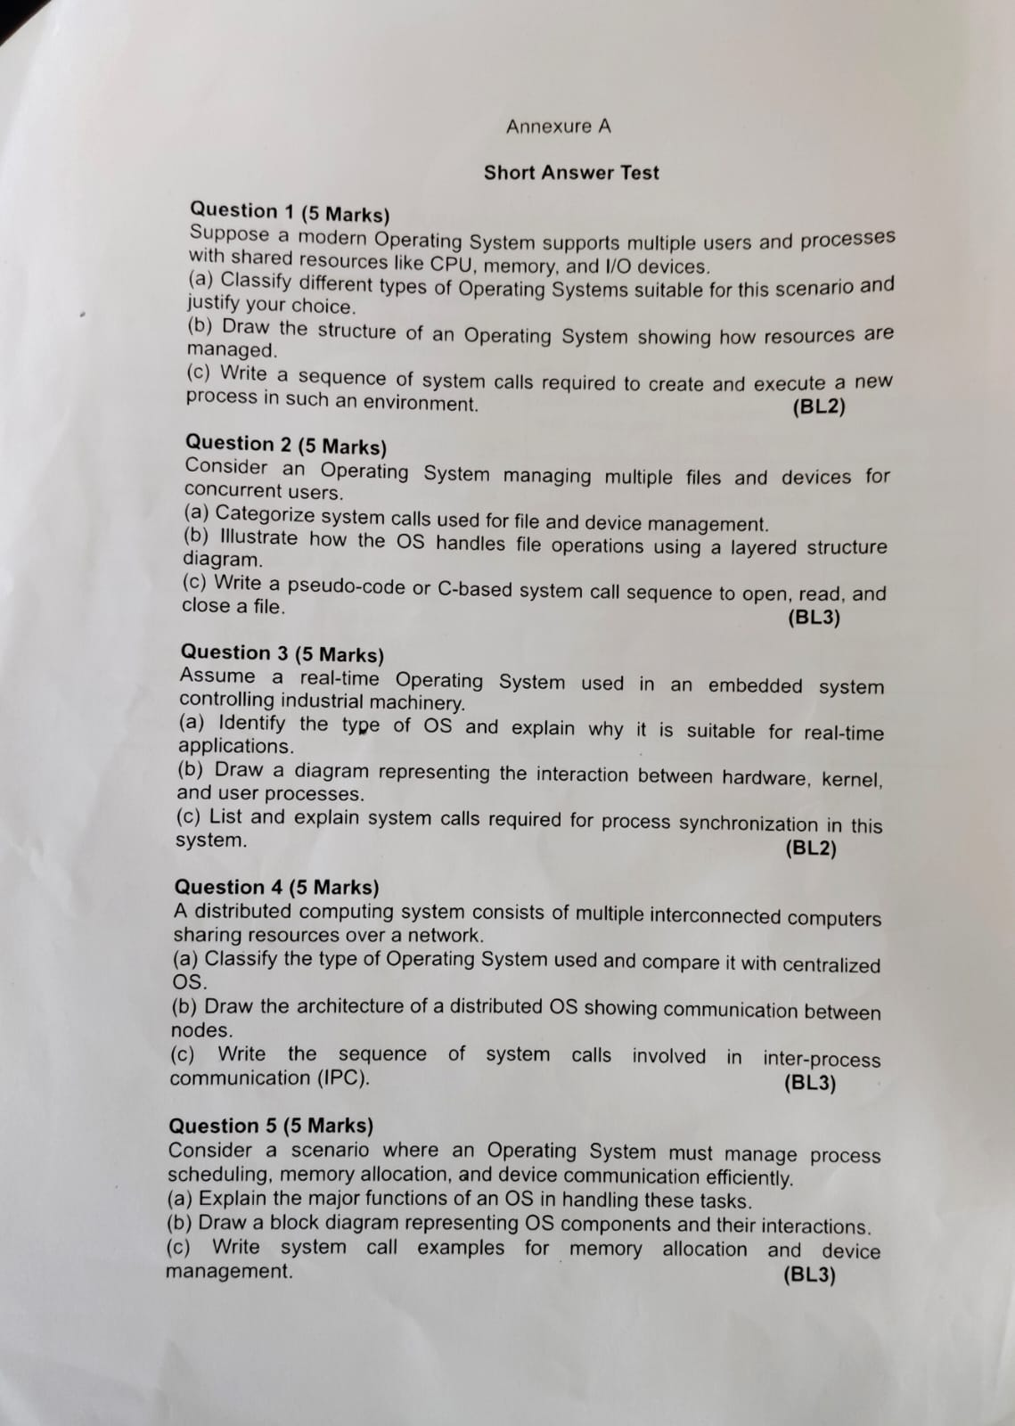
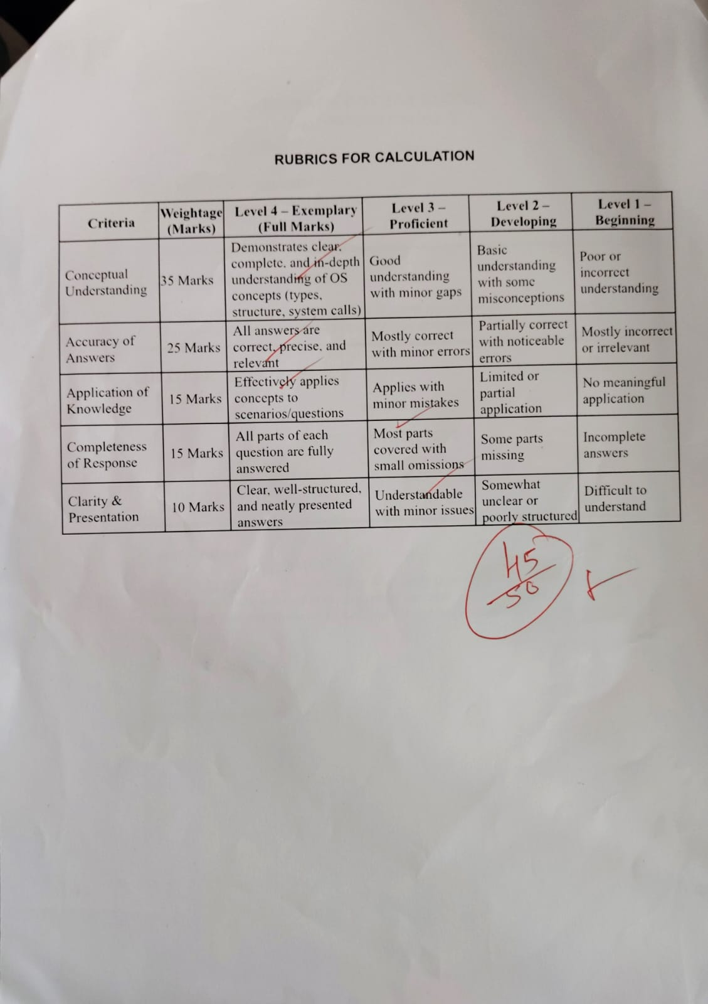
OPERATING SYSTEMS
CO 1 AT 1

Question 1 Multi-user and Multiprocessing Operating System

(a) Types of Operating Systems and Justification

A suitable choice is a multi-user, multitasking operating system with multiprocessor support. It allows several users to work at the same time and runs multiple processes while sharing CPU time, memory, and I/O devices.
- Batch OS: Executes grouped jobs with little user interaction; unsuitable for interactive multi-user work.
- Time-sharing OS: Divides CPU time into small time slices so users and processes receive responsive service.
- Multiprocessing OS: Uses two or more CPUs/cores to execute processes in parallel.
- Real-time OS: Gives predictable response within deadlines; useful when timing constraints are strict.

(b) OS Structure and Resource Management

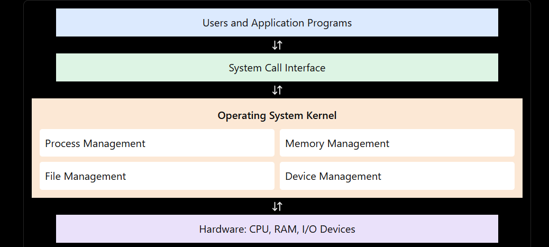

The scheduler allocates CPU time; the memory manager assigns and protects memory; device drivers control I/O hardware; and the file system organizes stored data.

(c) System Calls to Create and Execute a Process

Typical UNIX/Linux sequence:
1. pid = fork(); // create a child process
2. if (pid == 0) {
3. execvp("program", args); // replace child with program
4. _exit(1); // run only if exec fails
5. } else if (pid > 0) {
6. waitpid(pid, &status, 0); // parent waits
7. }
Question 2 File and Device Management

(a) Categories of System Calls

- File management: create, open, read, write, reposition/seek, close, delete, and get/set file attributes.
- Device management: request or release a device, read/write, get/set device attributes, and perform device-specific control using calls such as ioctl().
- Supporting calls: protection/permission calls control access, while I/O calls allow programs to communicate with devices through the OS.

(b) Layered Structure for File Operations

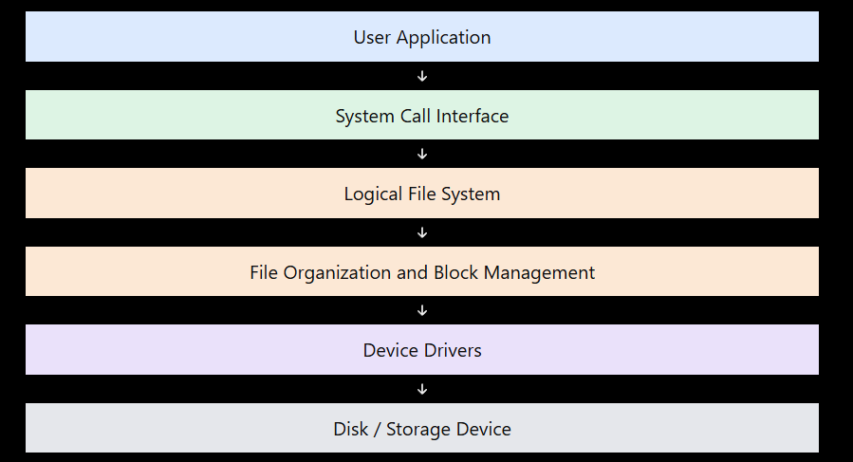

A file request moves down through these layers. The system-call interface validates the request, the VFS selects the appropriate file system, the block I/O layer manages data transfer, and the device driver communicates with the storage hardware. Results and errors are returned to the application.

(c) C Sequence to Open, Read, and Close a File

#include <fcntl.h>
#include <unistd.h>
#include <stdio.h>
int main(void) {
char buffer[128];
int fd = open("notes.txt", O_RDONLY);
if (fd == -1) { perror("open"); return 1; }
ssize_t n = read(fd, buffer, sizeof(buffer) - 1);
if (n == -1) { perror("read"); close(fd); return 1; }
buffer[n] = '\\0';
printf("%s", buffer);
if (close(fd) == -1) { perror("close"); return 1; }
return 0;
}

Question 3 Real-Time Operating System

(a) OS Type and Suitability

A Real-Time Operating System (RTOS) is suitable for industrial machinery because it is designed to respond to events within known time limits. A hard RTOS treats missing a critical deadline as system failure; a soft RTOS allows occasional deadline misses with reduced quality.
- Priority-based scheduling gives urgent control tasks fast access to the CPU.
- Predictable interrupt handling and bounded response times support timely sensor and actuator control.
- Synchronization and resource-management mechanisms coordinate concurrent tasks.
For safety-critical machine control, a hard real-time design may be required. The exact choice depends on the machine’s deadline and safety requirements.

(b) Hardware, Kernel, and User-Process Interaction

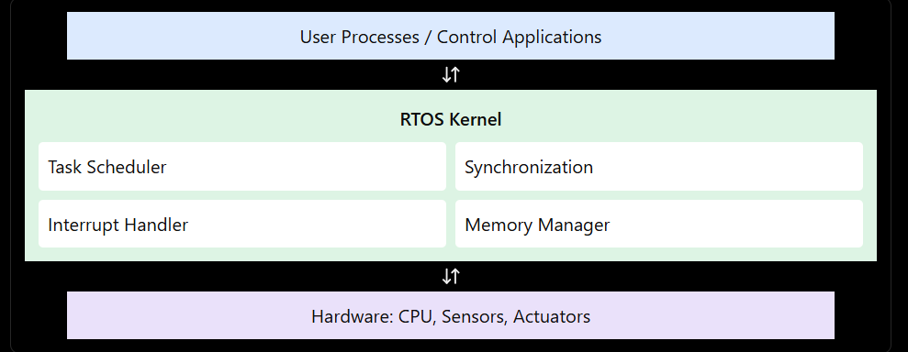
Hardware interrupts notify the kernel of events such as sensor changes. The scheduler selects the appropriate task, and device drivers exchange data with sensors and actuators. User tasks request protected services through system calls or RTOS APIs.

(c) System Calls / APIs for Process Synchronization

- sem_wait() / semaphore take: waits for a semaphore and may block until a resource is available.
- sem_post() / semaphore give: releases a semaphore and may wake a waiting task.
- mutex_lock() and mutex_unlock(): protect shared data so only one task enters a critical section at a time.
- condition-variable wait/signal: lets a task sleep until a required condition becomes true.
- message queue send/receive: safely transfers messages between concurrent tasks and can synchronize sender and receiver.
These operations prevent race conditions and coordinate task execution. Exact names differ by RTOS; some are library or kernel APIs rather than POSIX system calls.

Question 4 Distributed Operating System

(a) Classification and Comparison

A distributed OS manages multiple networked computers and aims to make their combined resources appear coordinated to users. It supports communication, resource sharing, workload distribution, and fault handling.
Compared with a centralized OS:
- Centralized OS: processing and resource control are mainly on one computer; administration is simpler, but that computer can become a bottleneck or single point of failure.
- Distributed OS: processing and resources are spread across nodes; it can improve scalability and availability, but requires network coordination and handling of communication delays and partial failures.

(b) Distributed OS Architecture

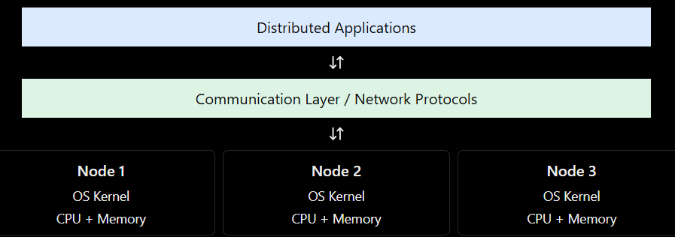
Each node has local hardware and kernel services. The network carries messages between nodes, while distributed services coordinate naming, file access, scheduling, and security. Network failure or node failure must be handled explicitly.

(c) IPC System-Call Sequence

A common client-server example uses sockets:
Server: socket() -> bind() -> listen()
-> accept() -> read()/recv()
-> write()/send() -> close()
Client: socket() -> connect()
-> write()/send() -> read()/recv()
-> close()
socket() creates a communication endpoint. bind(), listen(), and accept() prepare a server; connect() connects a client. send()/write() transmits data and recv()/read() receives it. close() releases the endpoint. The OS network stack transports messages between computers.

Question 5 OS Resource Management

(a) Major Functions of the OS
- Process scheduling: selects a ready process or thread, allocates CPU time, performs context switches, and balances responsiveness with fairness.
- Memory management: tracks memory usage, allocates and frees memory, provides virtual memory, and isolates process address spaces.
- Device and I/O management: uses device drivers, interrupts, buffering, caching, and queues to coordinate devices.
- Protection and coordination: checks permissions, isolates processes, and provides synchronization and communication mechanisms.
These functions work together to share resources efficiently while maintaining security, reliability, and acceptable performance.

(b) OS Components and Interactions

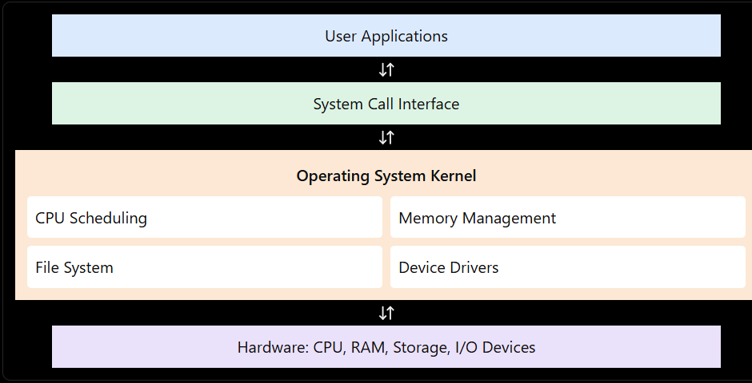

Applications request services through system calls. The kernel coordinates the scheduler, memory manager, file system, and drivers. Hardware interrupts and completion events notify the kernel when operations finish.

(c) System Call Examples

Memory allocation:
void *p = mmap(NULL, 4096,
PROT_READ | PROT_WRITE,
MAP_PRIVATE | MAP_ANONYMOUS, -1, 0);
/* use p, then release it */
munmap(p, 4096);
mmap() requests a memory mapping and munmap() releases it on POSIX systems. For dynamic heap memory, programs commonly use malloc()/free(), which are library functions rather than direct system calls.
Device management:
int fd = open("/dev/example", O_RDWR);
if (fd >= 0) {
/* read(fd, buffer, size); */
/* write(fd, buffer, size); */
/* ioctl(fd, command, argument); */
close(fd);
}
open() obtains access to a device file, read()/write() transfer data, ioctl() performs device-specific control when supported, and close() releases the descriptor.
Conclusion:
The OS manages CPU scheduling, memory, files, and devices to ensure efficient and reliable system operation.

